Name: Amol Shivaji Tambekar Roll No:54 Batch:3
1. Horizontal Partitioning
RANGE Partitioning
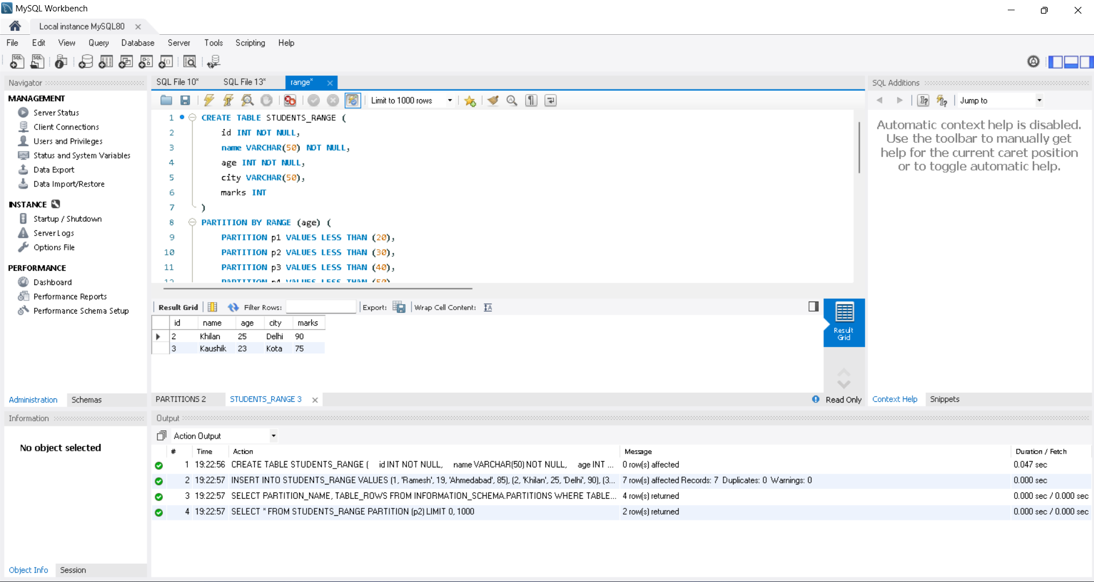

LIST Partitioning

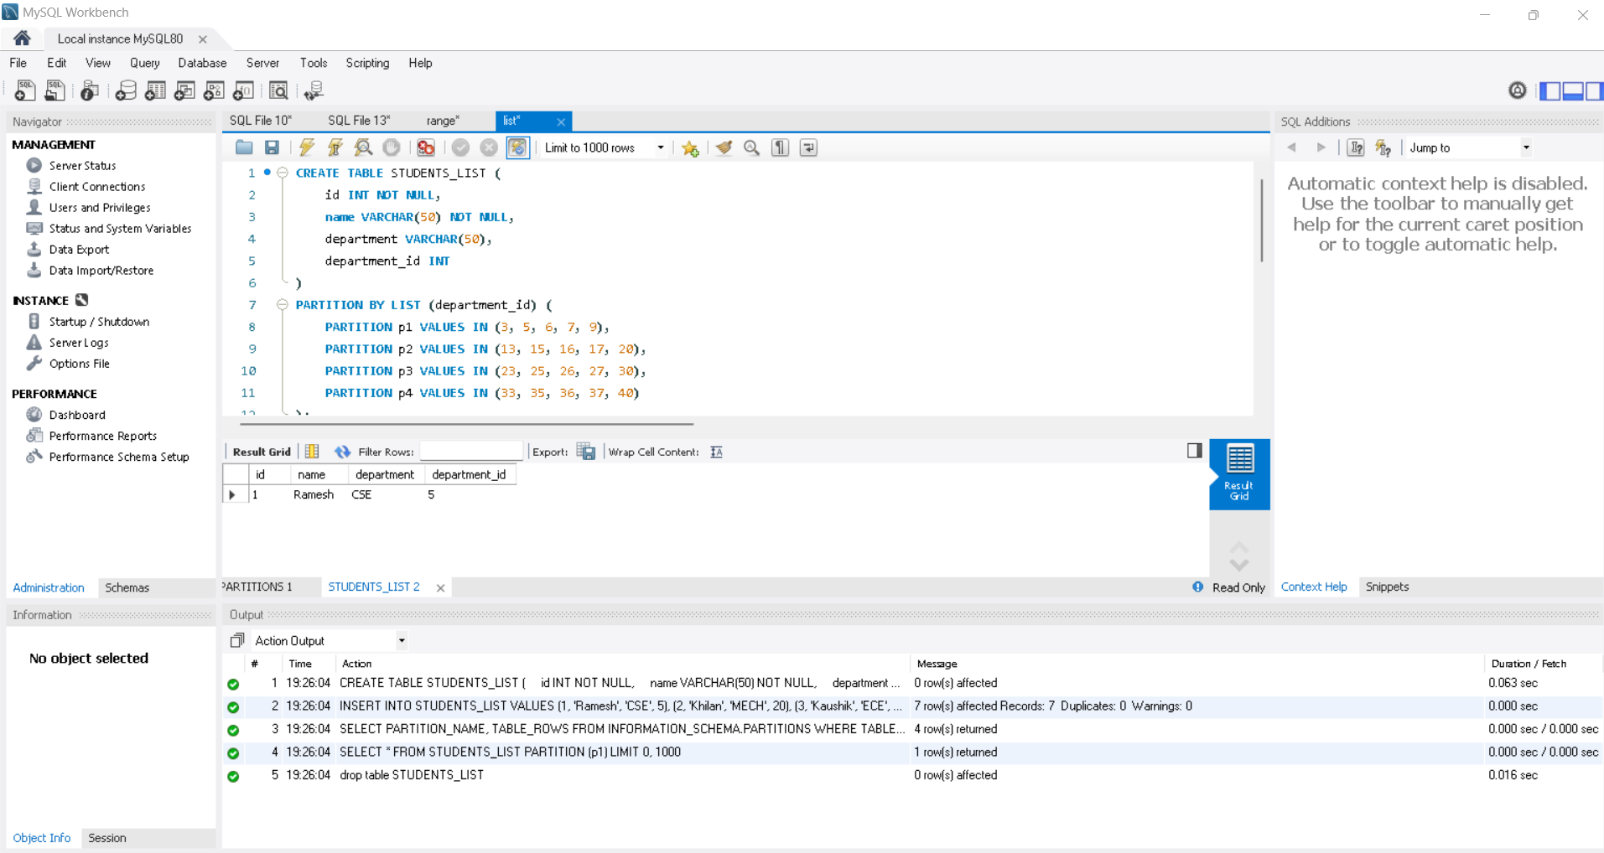
HASH Partitioning

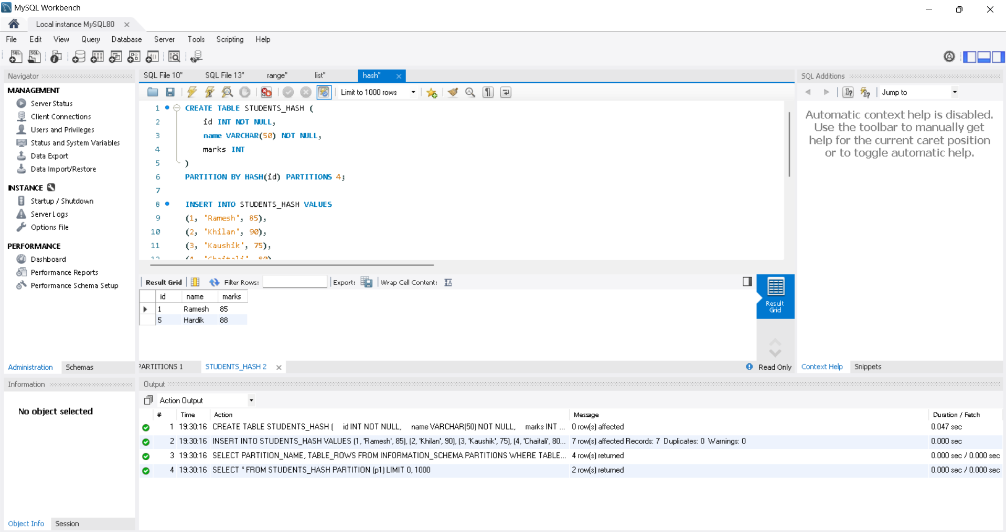

KEY Partitioning

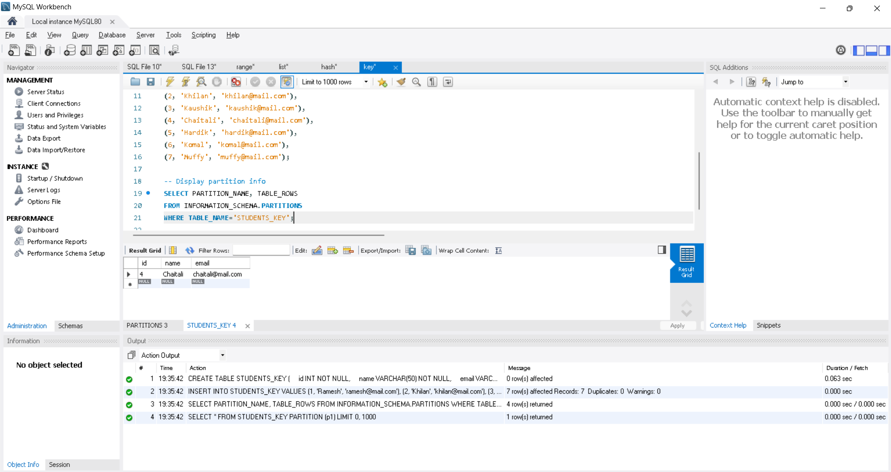

Sub-partitioning

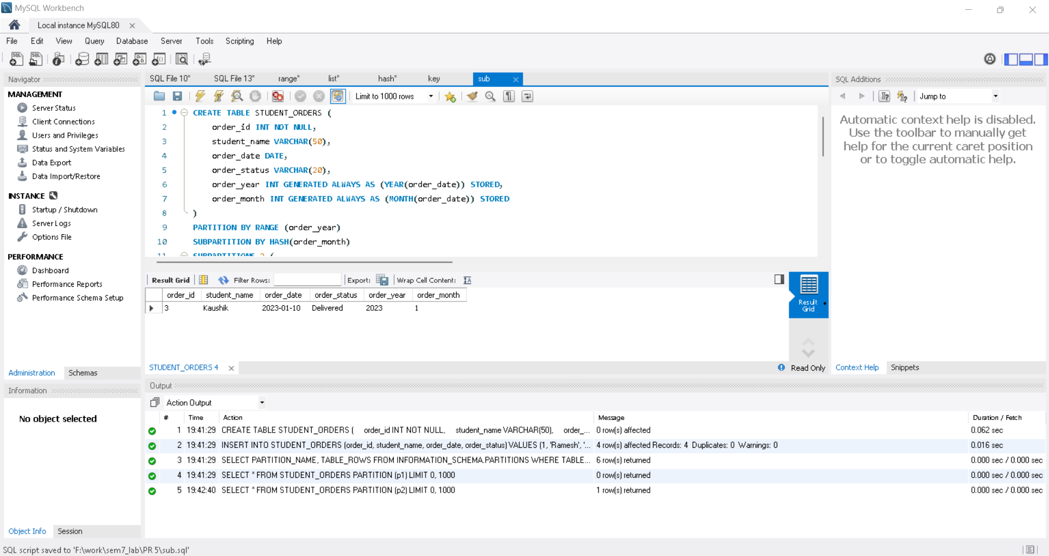

2. Vertical Partitioning

RANGE COLUMNS Partitioning

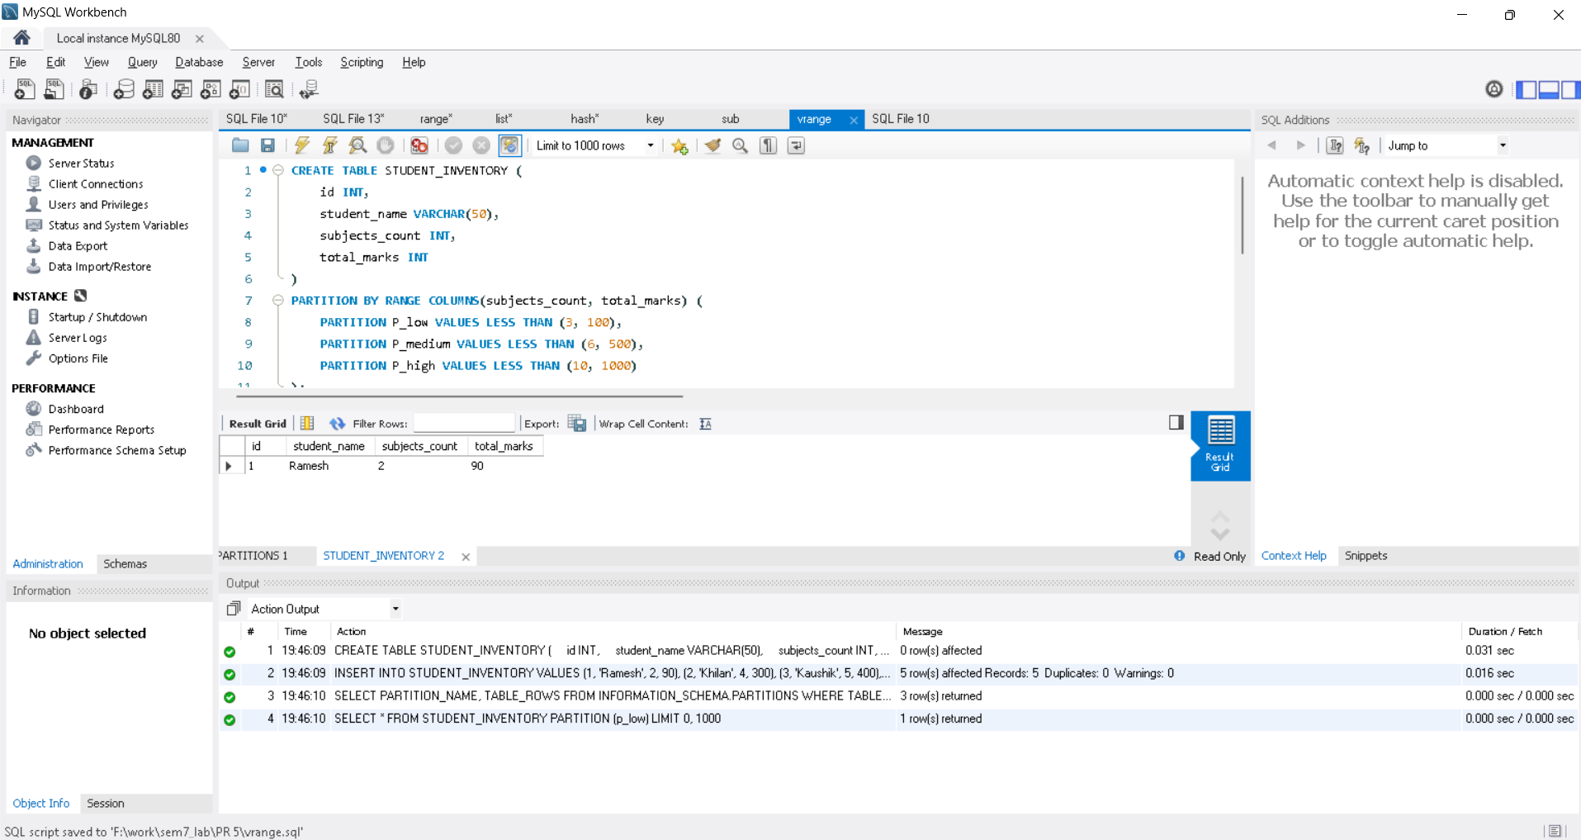
LIST COLUMNS Partitioning

